EASL meetings- Abstract submission guideline

Below you will find the major key points and rules needed to prepare your abstract for submission.

Template

Topic
Download the word template on the abstract submission platform

Title
Choose your track and topic so that it will be reviewed in the appropriate category

Title should be on a single line (no paragraphs) Length is 50-250 characters (excluding spaces)
Do not use all capital letters
Do not use any abbreviation in the title
Do not put a period at the end of the title
Title should not have each word capitalised.

Examples:

- This is a correct example title for your abstract

✗ THIS IS AN INCORRECT EXAMPLE TITLE FOR YOUR ABSTRACT. (all caps)

✗ This Is An Incorrect Example Title For Your Abstract. (each word capitalised)

Authors

- Mandatory fields: Complete first name (not only the initials), last name, email and country
- Indicate corresponding and presenting authors (if different from submitter)
- When copy/pasting names, make sure there is no space after the name

Affiliations

- Department (optional), institution/company, city, country
- Do not use all capital letters and do not capitalise the first letter of each word
- When entering new author’s affiliation, if the affiliation the same make sure it is written the same way

Abstract body

- The following blocks are available in the abstract body and appear in the word template:

Background and Aims:
  - Method:

Results:
  - Conclusion:

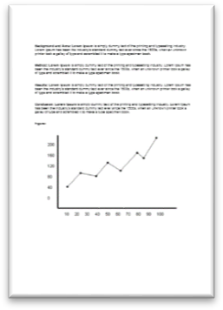
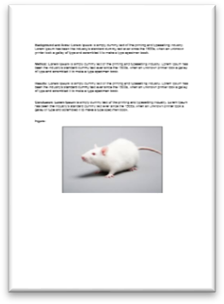
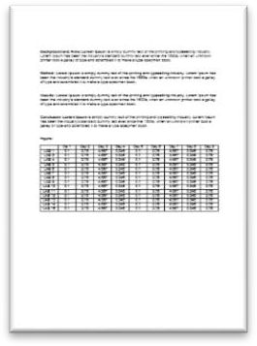
Figure: limited to one figure OR one image OR one table per abstract see example below:

OR OR

IMPORTANT: Should you upload more than one figure OR one image OR one table we will keep the first one and automatically delete the other(s).

- Do not change the blocks titles (Background and Aims, Method, etc), the system will not allow you to upload a document with modified titles.
- In total, the ideal number of block characters (excluding spaces) should be between 500- 2500
- The characters of the table are included in the count of the total number of characters used
- You do not need to enter content in all blocks
- Do not leave spaces between each block
- Write immediately after the block’s semicolon example:

Correct
- Background and Aims: Many acute liver diseases are accompanied by … Wrong
✗ Background and Aims: Many acute liver diseases are accompanied by …

- Main formatting rules:
  - Define all abbreviations at first use
  - Decimal point should be a period (2.5)
  - Put spaces between signs and number (2.5 = a)
  - Significance value should be small ‘p’, not bolded nor italic (p > 2.5)
  - Avoid using symbols (use “alpha”, not α). Never use the “symbol” font

Postdoc and Trainees, Nurses and AHP Bursary

If you are aged 35 or under and/or still in training (at the time of the first day of the event), and you are an EASL member, you can apply for a travel bursary
- Upload proof of age or proof of training or employment letter (nurses and AHP)
- Provide your EASL membership number (not applicable for nurses and AHP)

Disclosure-Conflict of interest

- List ALL the conflicts of interest even if unrelated to the abstract, for all the authors
- Indicate the company(ies) for the different types of conflicts for each author
- If the type is not listed, use the “other” field and indicate the nature of the conflict
- In case of use of off-label products, disclose the name of the product and the manufacturing company

Modifications

- Do not withdraw a paid abstract submission
- Modifications on draft abstracts can be done on the platform until the submission deadline of the given event

